Briefing of Hardware System for Multi-Modem

For our project, we will be implementing both the Luma-X UV UW-O modem and Popoto PMM 4511 UW-A modem into a single system utilizing the Raspberry Pi 5 as the main control unit. The Pi will be integrated onto a PCB which also includes a power management system that will use the BlueRobotics LI-4S-15.6Ah battery and DC/DC converters. We will wire each component in the system based to either a 5V rail for the Pi, sensors, and a camera, as well as a 24V rail for each of the modems. The PCB will then be installed inside a chassis within a waterproof case and utilized as a unit to communicate information and simulate the true integration into the FishBot. Each unit will be slightly different based on function:

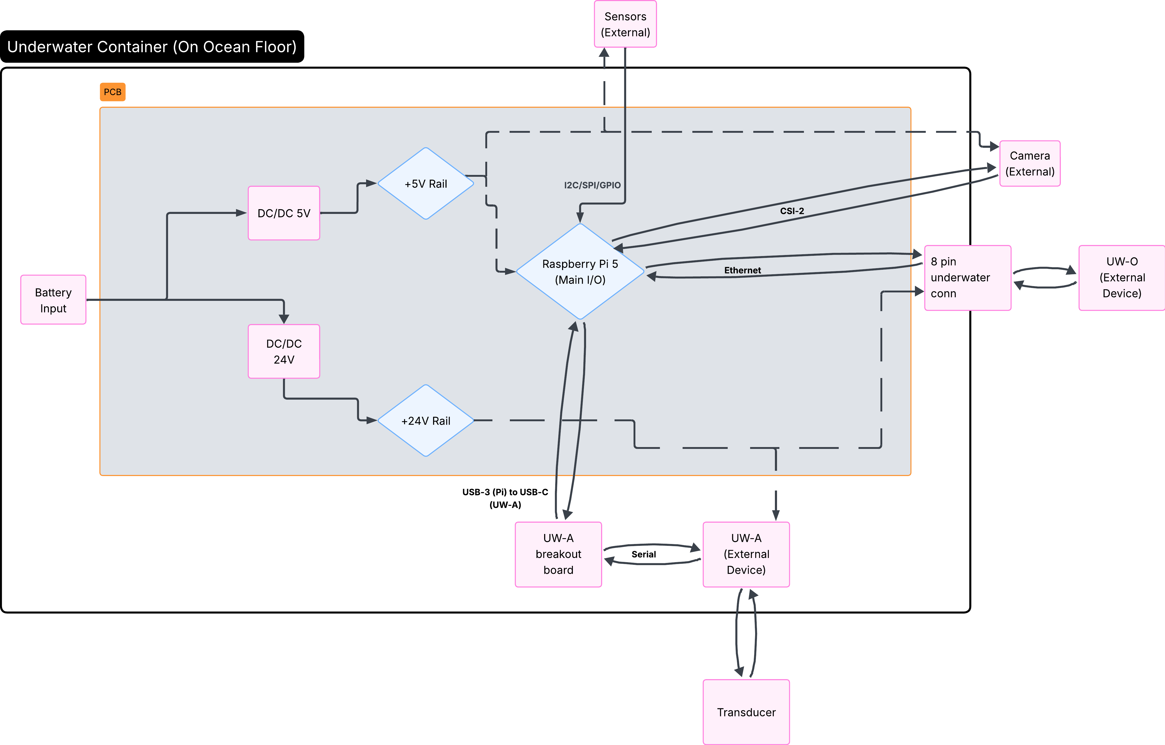
This first block diagram is a high level view of one of the units that will be placed on the ocean floor to grab live video footage as well as sensor data. The optical modem will be primarily utilized within this demo example as it has the higher bitrate and will be transmitting a video stream captured by a Raspberry Pi Camera Module 3 within a waterproof case. The acoustic modem will be used to transmit sensor data to conserve bandwidth, as well as if the bit error rate of the optical modem becomes too large due to environmental factors the system will switch to the acoustic modem to communicate. The Luma-X modem has a fully functional underwater casing therefore it will be attached to the outside of the container for minimizing distortion. The PMM4511 has to remain within the container, but will be connected to a transducer wired to the outside of it to perform its communication. Lastly, waterproof sensors will be attached to the outside of the container to gather environmental data.

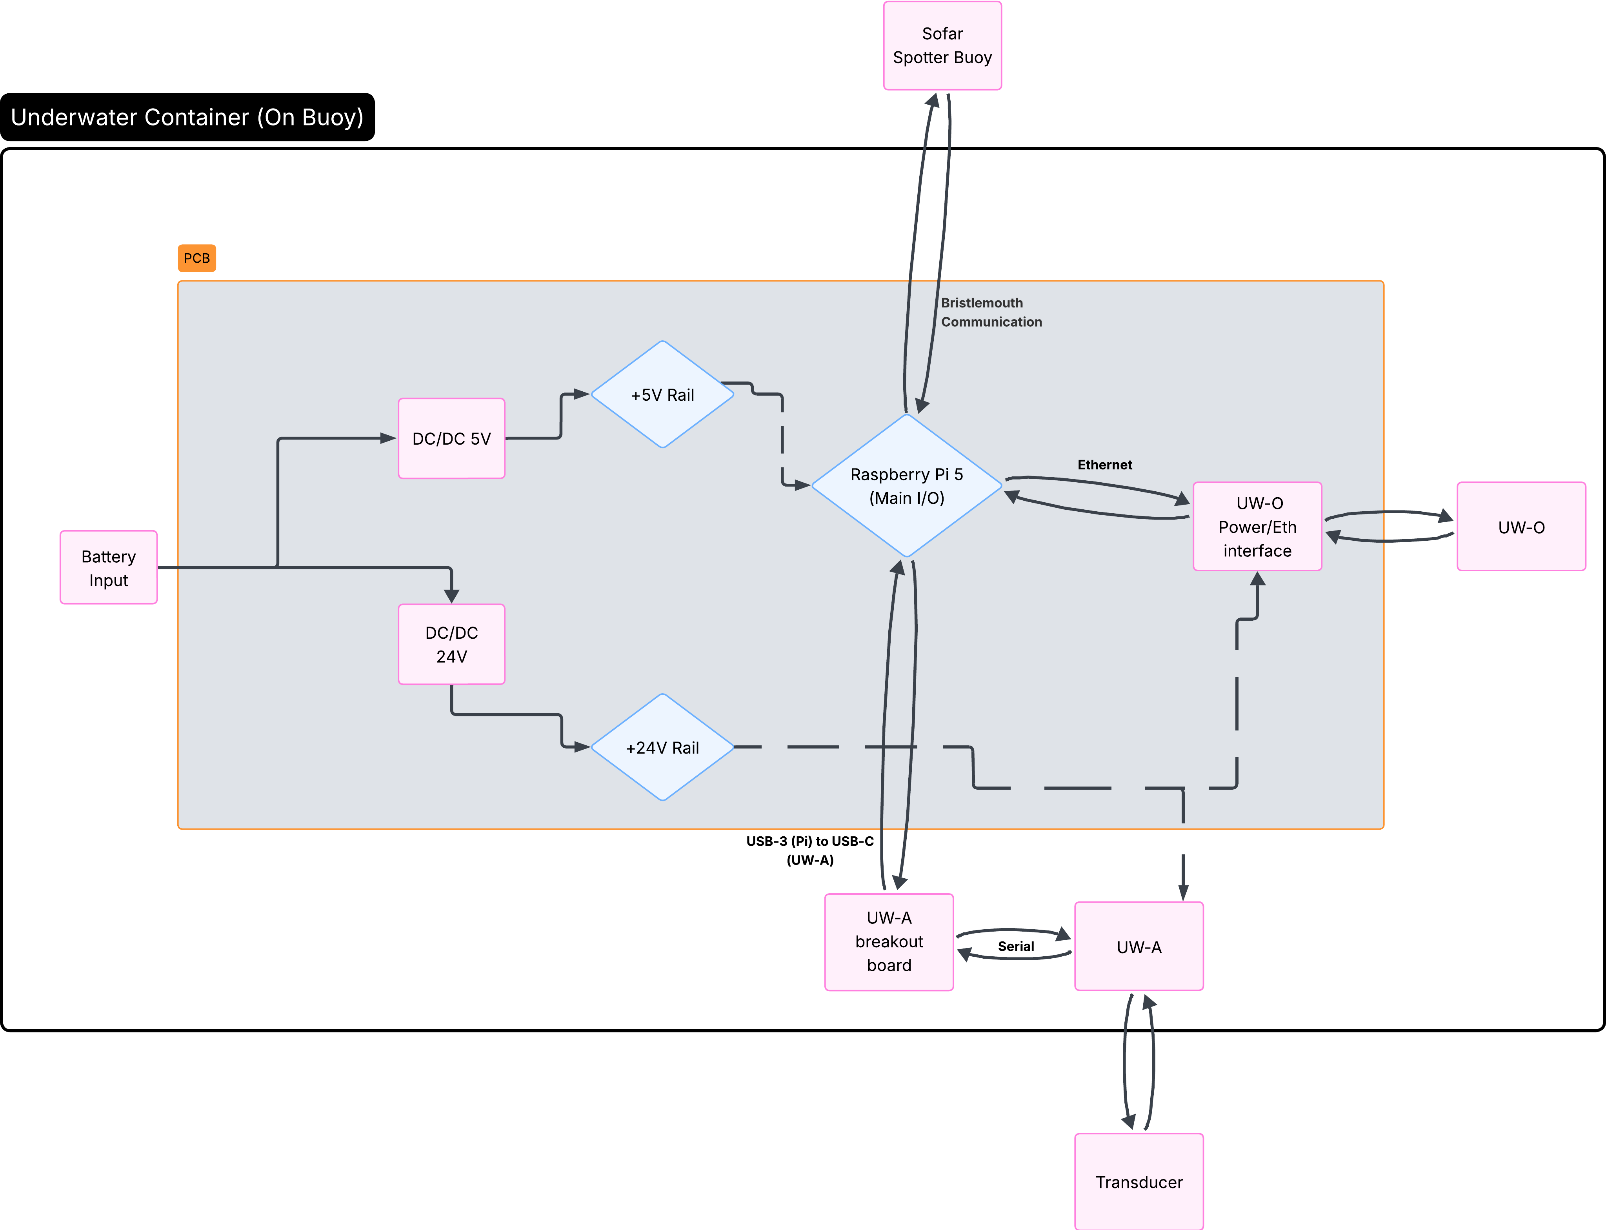
This second unit is slightly different than the first in that the Pi will be interfacing with the Sofar Spotter Buoy through Bristlemouth standard. Additionally, the second Luma-X modem is not contained within a waterproof case, and therefore must stay inside the container. This bare modem also has exposed soldering directly for Ethernet and power connections and is susceptible to breaking, therefore including an interface between the PCB and modem for power/Eth is necessary. Other than those two changes and the exclusion of a camera/sensors the second unit is identical to the first.

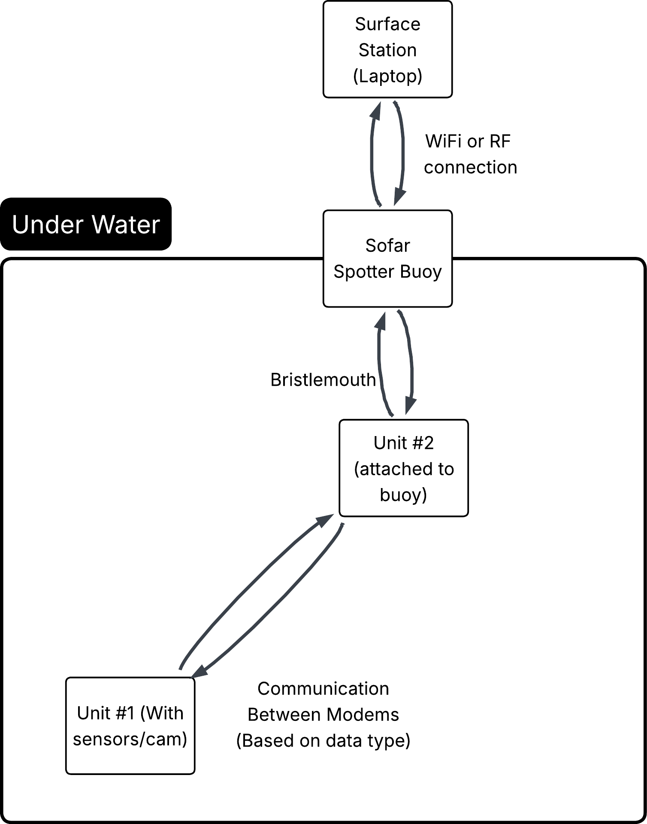
This diagram is meant to show the operation of the final system and what will be demoed. The first unit will be anchored to the sea floor and collect sensor/video data and send it back to the second unit in real time. Then, the second unit will be attached to the Sofar Spotter Buoy via Bristlemouth and relay the information gathered transferred through the modems to a surface station, which will receive the data through some wireless connection (haven’t gotten there yet).

Currently, the design of the PCB is being done through the use of KiCAD for the PCB design and ADS for simulation. The difficulties I have run into is how to handle the UW-O interface for the second modem and understanding factors such as EMI within the design to ensure proper function with minimal interference. For the power management system I will use a buck converter for the DC/DC component that will take the 14.8V input of the battery and step it down to 5V for the 5V rail, and a boost converter to step up the 14.8V to 24V for the modem power rail. Initially, the design was slated to use an ESP-32 to handle the decision protocol for which modem to use to reduce power consumption, but for integration into the KnifeBot I was advised to use the Raspberry Pi 5. Additional PCB components include the sensors and camera, and later for the implementation into the KnifeBot the Master/Slave motor controllers.

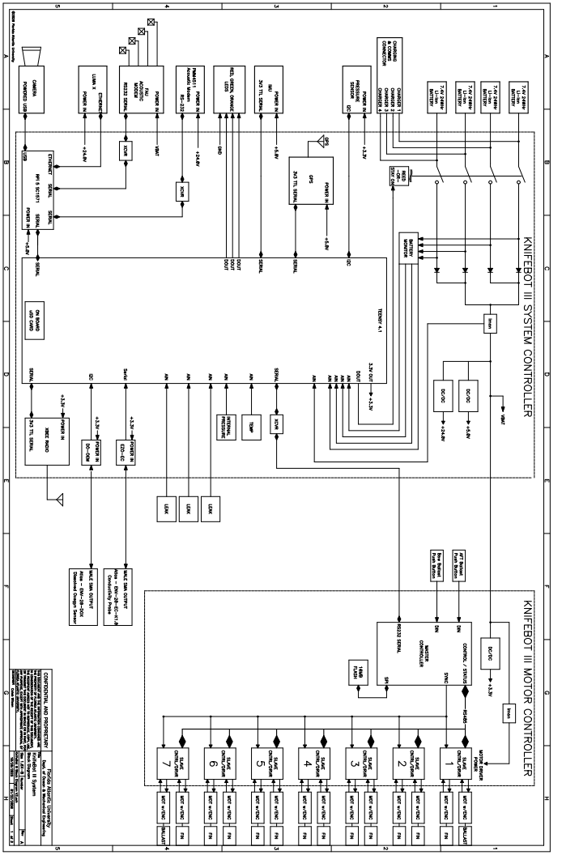

A comprehensive parts list is currently being assembled, however I would like to finalize some more details with the PCB and the implementation of the buoy before I finalize that list. Additionally I will be including the parts in the above diagram in the comprehensive list as well. In the mean time, the parts that are needed will be ordered through Dr. Sklivanitis ASAP. Along with the parts list there is an existing power budget sheet that includes the parts for the demo, but not the KnifeBot specific components. I will also be integrating the components such as the motor controller and the FAU UW-A modem into the power budget at a later date.

